LOGGING INTO CRUZPAY
1. Go to http://cruzpay.ucsc.edu
CRUZPAY: STUDENT / HOURLY EMPLOYEE QUICK START GUIDE

USING MULTIPLE PAY CODES
1. If you need to use a pay code other than Regular Hours, click the green symbol for the
2. Click the Click Here to Enter CruzPay link or click on the CruzPay logo.
3. Enter your CruzPay ID (this is the part of your UCSC email address before the '@' sign) and
CruzPay password.
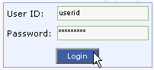4. Click Login or press Enter.

The first time you log in, you will be prompted to change your password.

ENTERING YOUR TIME
1. After successful login, you will be directed to the dashboard. Click on Enter My Hours in the
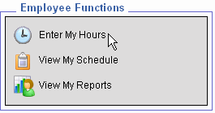Employee Functions box.
appropriate week and a new row will appear above the existing row.
2. Click the Pay Code drop down menu, select a pay code and enter time in the new row.
3. If you need to delete a row, click the red symbol in the row to be deleted.
4. Select OK or press Enter.

SAVING YOUR TIMESHEET
Anytime you enter or change information on your timesheet, you will need to click the
button.

SUBMITTING YOUR TIMESHEET
1. If you have no hours to report for the pay period, please submit your timesheet to indicate to your supervisor and timekeeper that your timesheet is finalized.
2. In the Time Entry window click the button. This indicates your timesheet is ready for your supervisor’s online review and approval.
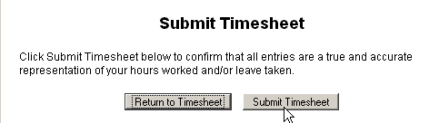3. Click Submit Timesheet when you receive the Submit Timesheet pop-up window. If this window does not appear, please refer to http://cruzpay.ucsc.edu/techtoolbox/popup.html

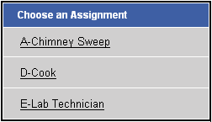2. If you have more than one student job,
you will be asked to Choose an Assignment.

Be very careful to enter hours on the correct timesheet!! You will have one timesheet for each assignment in each pay period – mistakes will cause your time- sheet to be rejected; and may delay payment!

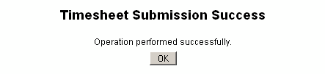4. The process is complete when you receive the Timesheet Submission Success pop-up window and click OK.

3. The system will display the first, unprocessed timesheet when you enter. Click the Pay Period
drop-down menu to select the appropriate pay period.
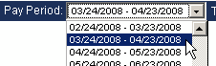

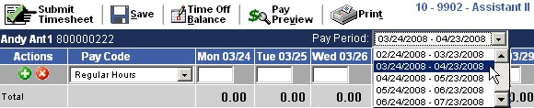4. Student/hourly employees should enter time worked and leave taken to the nearest quarter hour. The default pay code for a student/hourly employee is Regular Hours.
LOGGING OUT OF CRUZPAY
1. Make sure to Save your work before logging out.
2. Exit the system at any time by clicking on the link at the top right of the window.

NOTES
 Review and validate all Exception Messages appearing at the bottom of your timesheet. See http://cruzpay.ucsc.edu/etoolbox/studenttoolbox/studentmanual/index.html
 Contact your Timekeeper for questions regarding UCSC Time Reporting policies, work study balances or payment concerns. For a list of Timekeepers by unit, visit http://cruzpay.ucsc.edu/timekeeper.html.
 Do not use the standard browser navigation buttons, e.g. page back, page forward, etc.
 For more detailed instructions and reference materials, please see the Employee Toolbox at http://cruzpay.ucsc.edu

